**Education platform**

Analysis

**Introduction :**

Education platform is a Web-based system for training programs and information sharing between individuals giving them the flexibility to access it from their workplace or home.

The Education platform goes far beyond conventional training by sharing every idea, managing individual training requirements and reporting training progress. Most E-learning platforms are Web-based and facilitate “anytime, anyplace, any pace” access to learning content and administration.

Education platform enable an organization to effectively train a large group of students spread across the organization.

**Goals :**

The overall goal is to help students develop relationships with other students and help them facilitate communication between students and exchange ideas and allow students to recover what they are studying at any time.

**Objectives:**

1. Facilitating students' access to threatening forms of questions and tests

2. Help students to exchange ideas, which help to think creatively.

3. Accessibility of educational materials.

4. Encourages students to participate.

5. Provide simple, universal access to information and services for all faculty, staff, and students.

**Critical success factors :**

1. Increase interaction between students and help each other understand the content of the material they are studying

2. Share appropriate educational content for students

3. Provide various forms of questions, exams and tests to be a bank of questions

5. Allows all students at all levels to take advantage of the content of the learning platform.

**Similar Products :**

1-Udemy

2-Udacity

3-Coursera

4-EDX

**Features of the projects :**

**1-courses and their status (in progress, completed, active, inactive, etc.)**

**2-Easy to use interface :**

-Instructors and students must be able to navigate through the website smoothly.

**3-Assessment tools :**

-Online quizzes and tests can help students pinpoint areas of improvement, based on subject or skill.

**4-Access to the Help Center**

**5-Live Feedback :**

**-**One-on-one interaction with instructors inspires confidence and helps students better understand their current assignments.

**6-Instructor can record course and upload it .**

**7-or Instructor can advertise of starting course (after eg : 2 weeks) and students can enroll on it and teach the course online.**

**Product functions :**

Login : enable user to login website

Signup : instructor/student can register by his personal details.

Search : enable user to search for certain course .

Create : enable instructor to create new course.

Enroll : enable student to register on course.

User Classes and Characteristics:

Student : anyone interested in learning.

Instructor: person that create courses.

## *2.3* Operating Environment:

• Windows 2000  
• Windows XP  
• Windows Vista  
• Windows 7  
• Windows 8  
• Windows 10  
• Mac OS X  
• Linux

Education Platform Stakeholders :

1- Students :

Students are motivated to use e-learning to gain access to higher education. For some, it may be a component of a traditional course, while for others entire courses may be entirely online.

Particularly for this second group, e-learning may create access to higher education that they would not have otherwise.

**2- Instructors :**

Instructors may be motivated to use e-learning in their courses for a variety of reasons. For example, they may be encouraged or pressured by their institutions; they may wish to reach a broader audience of students; or they may have an interest in the benefits of technology mediated learning.

**3- Educational Institutions :**

Educational Institutions provide distance learning, including e-learning, to allow them to access a larger pool students.

Often, budgetary restriction is the primary issue for institutions. Tight budgets make it difficult to implement broad, campus-wide e-learning solutions.

There is a tendency for individual departments to implement their own solutions, which may not be consistent with the rest of the institution . This reduces the potential for cross-departmental efficiencies, and can make the process more complicated for faculty, staff, and students, particularly if they are involved with more than one department.

**4- Technology Providers :**

Technology providers are motivated to provide products that will result in effective learning. Standards are an important consideration for this stakeholder as well. Since educational institutions often have many solutions implemented by various departments, adherence to standards facilitates interoperability.

**5- Employers :**

Employers are increasingly motivated to consider e-learning as a higher education alternative. Denying the value of e learning will restrict their pool of potential hires. It will also limit the availability of courses and professional development activities that their employees may participate in.

User Documentation:

* for Register in website

The user enters data :

-full name

-username

-user phone number

-user E-mail

-user password

-confirm password

The application verify the E-mail to valid E-mail by sending unique code in verified message.

-user enter the code as input

* For login to website

The user enters data

-his E-mail

-his Password

Application check from DB e-mail and password entered.

* For Search about course

-student enter his prefer course name

-select the course

* The student can enroll course by press Enroll now button.

**External Interface Requirements**

User Interfaces:

1.login

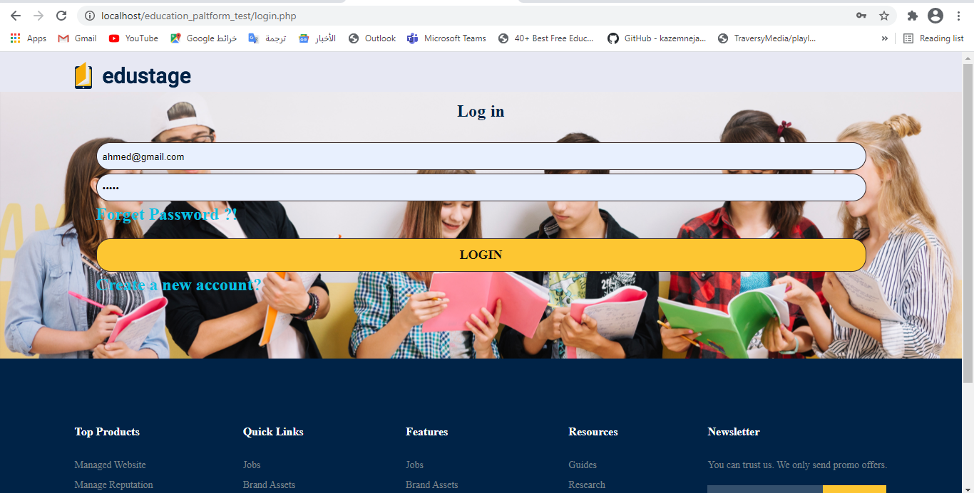

2.Register

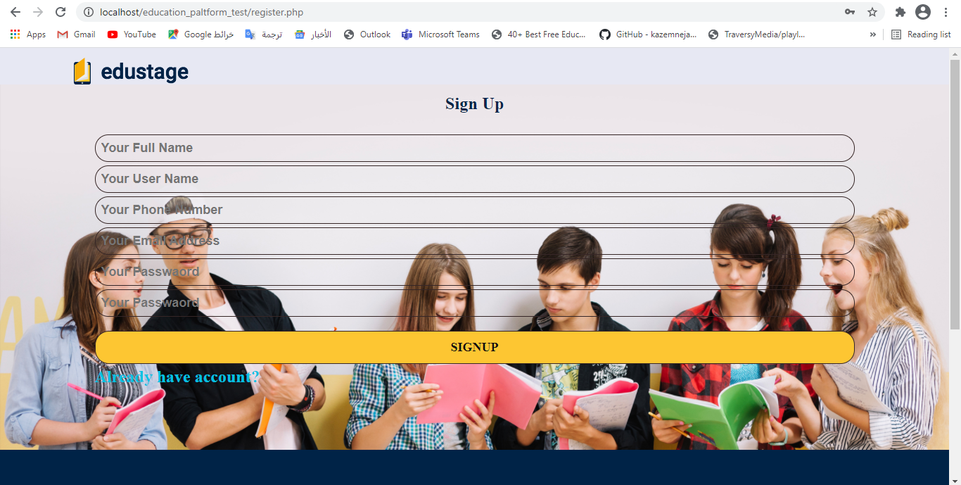

***3.Home page***

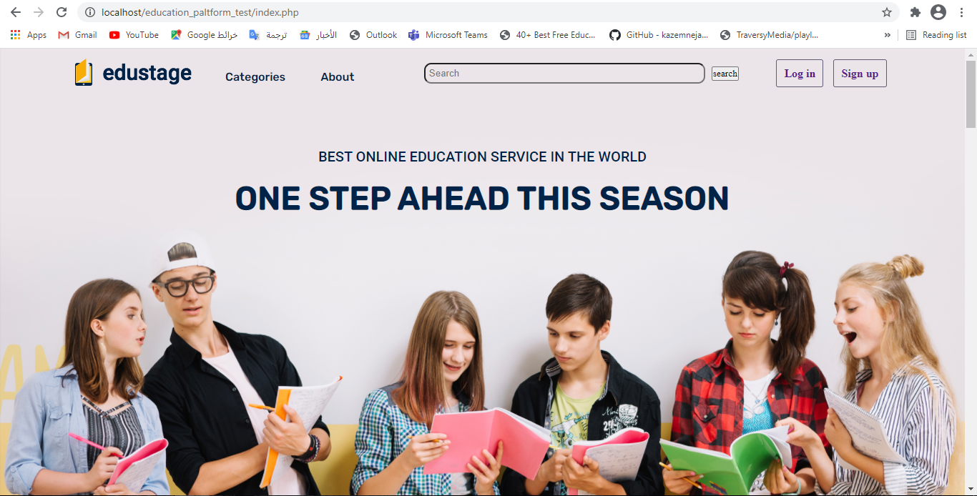

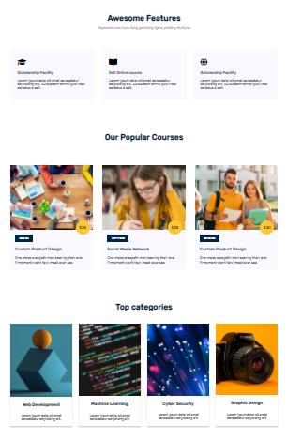

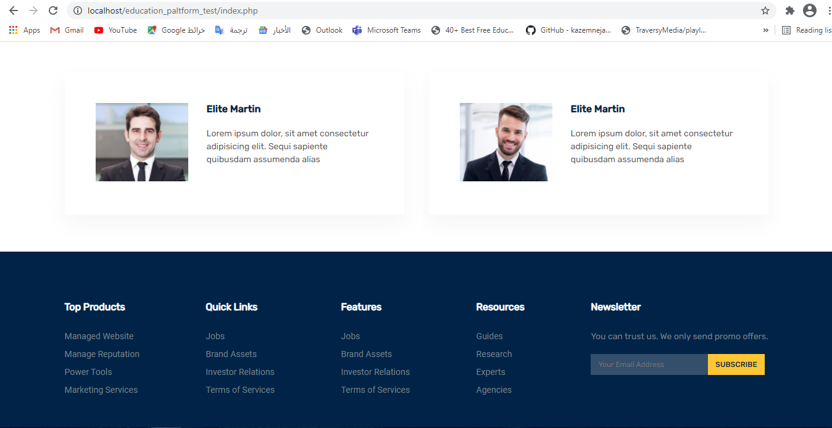

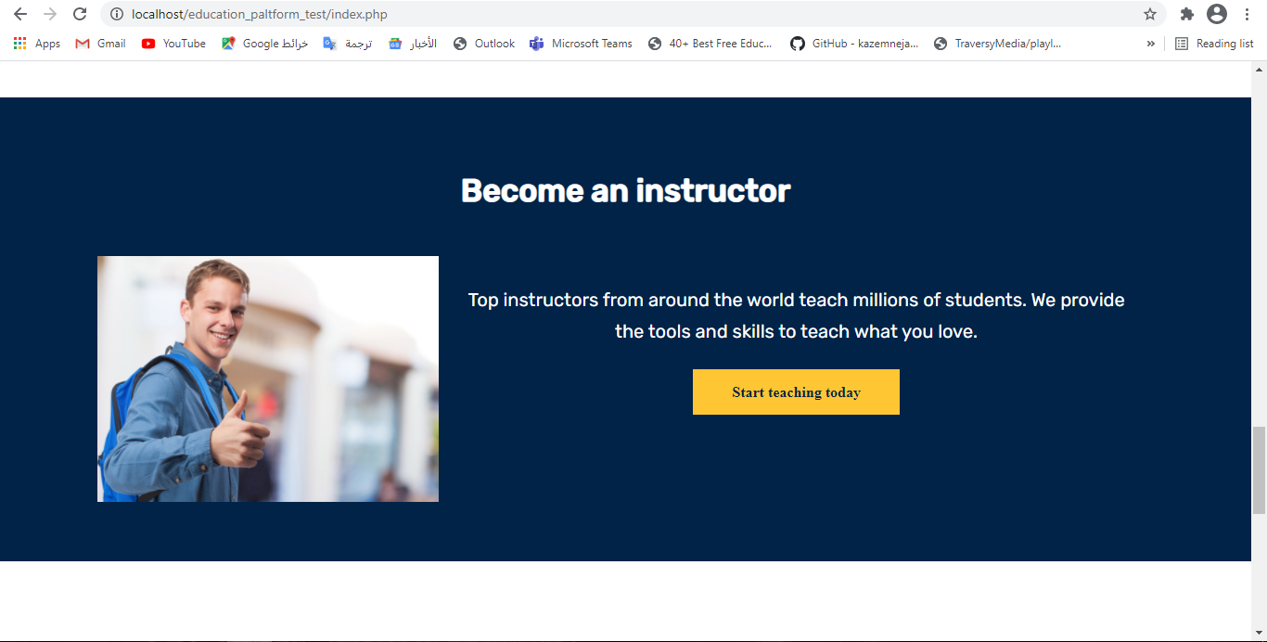

***4.Student page :***

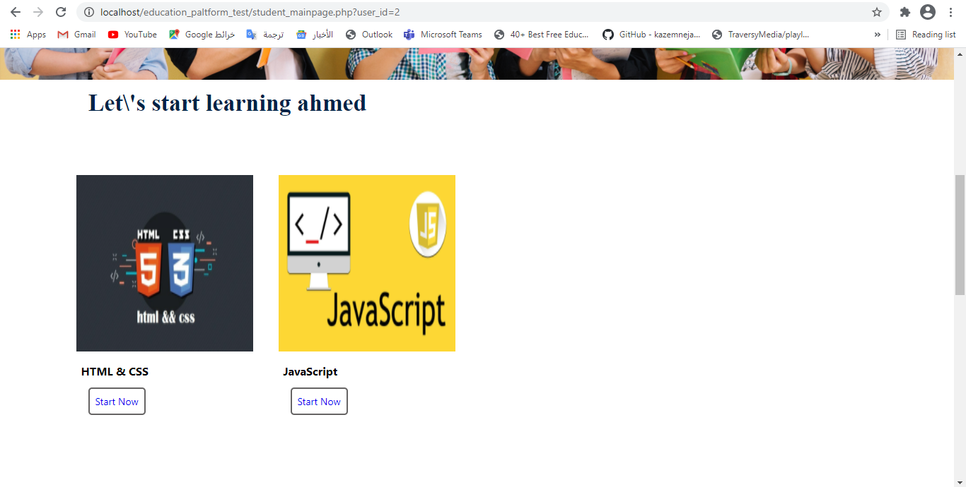

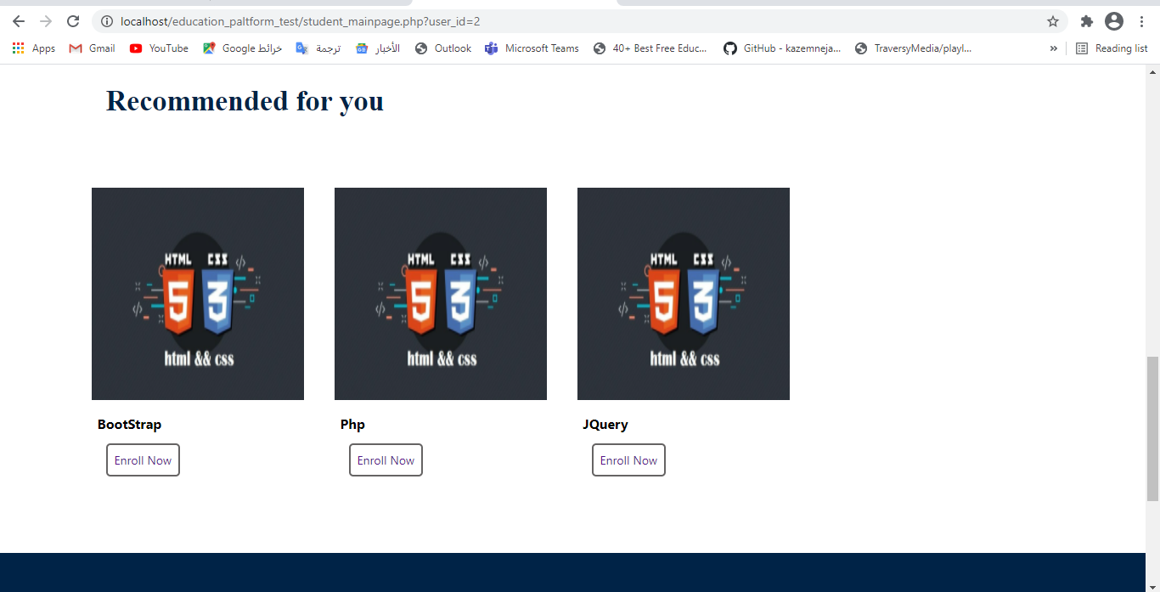

***5.search:***

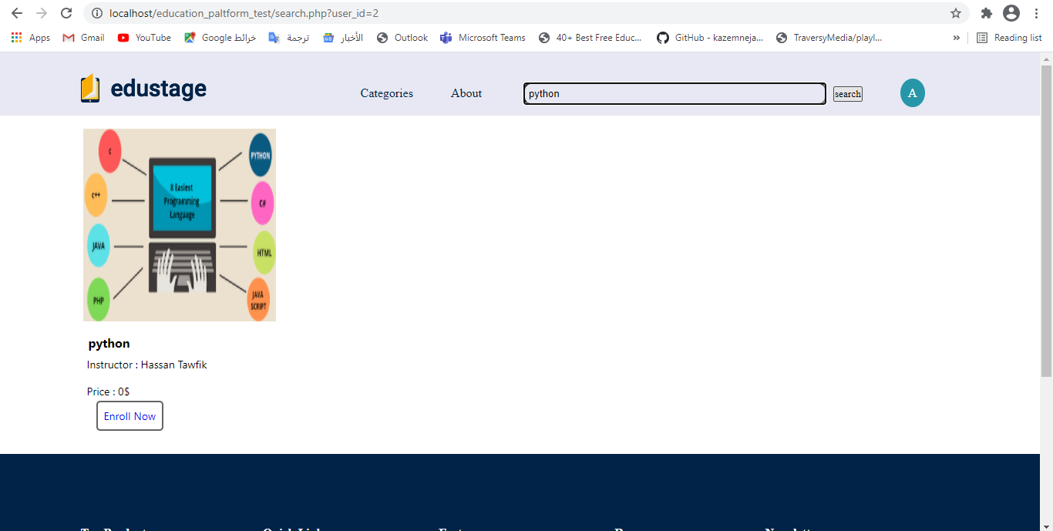

***6.Instructor courses page:***

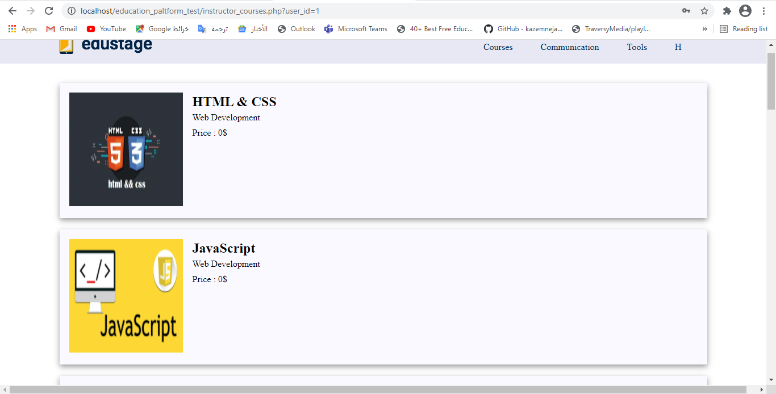

***7.instructor create course:***

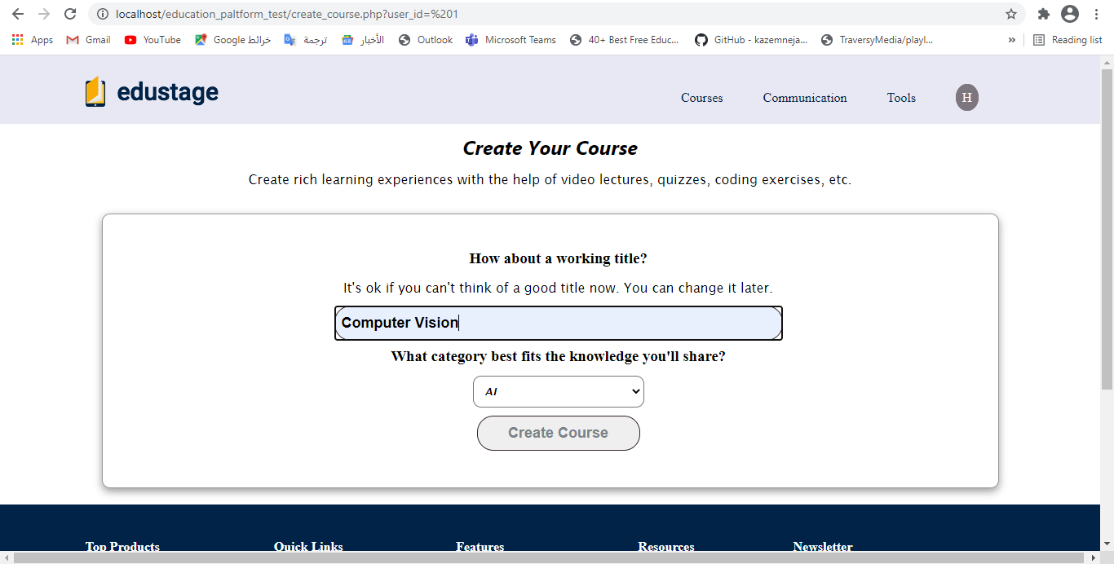

***8.instructor communication:***

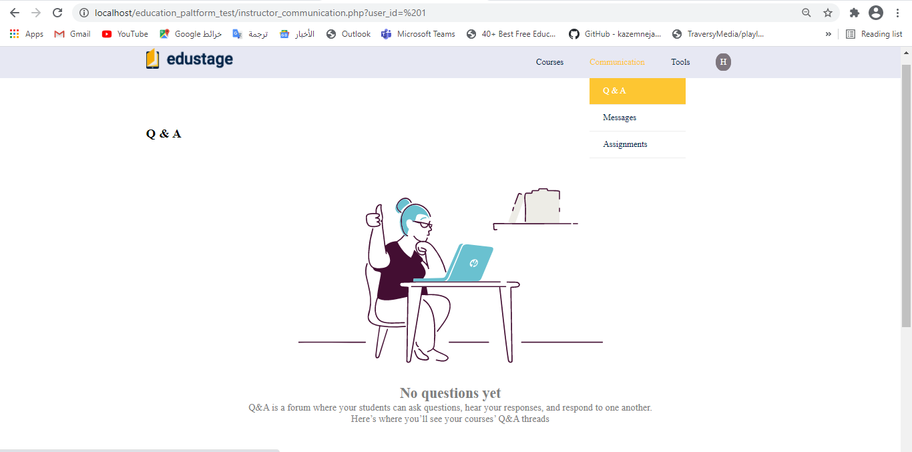

***9.instructor tools:***

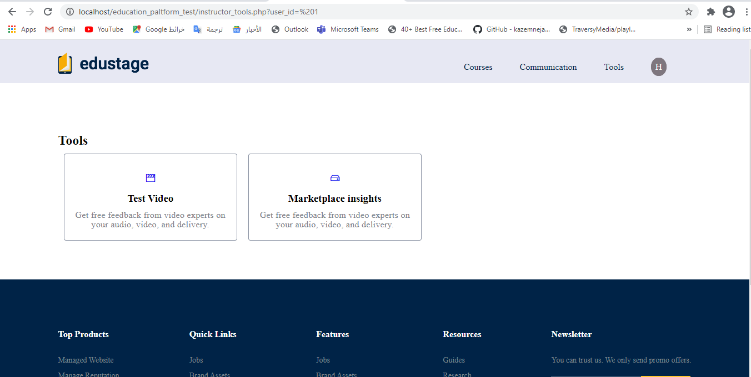**Functional Requirements :**

**Instructor :**

• FR1: Ability to login and update profile.

* • FR2: Ability to logout after the completion of process.
* • FR3: Register data.
* • FR4: Ability to create, edit or delete courses.
* • FR5: Ability to create, edit or delete test.
* • FR6: Ability to create, edit or delete assignments.
* • FR7: Ability to start meeting

**Students :**

* • FR1: ability to download tests
* • FR2: Ability to view assignments.
* • FR3: Ability to share solutions of assignments.
* • FR4: Register data.
* • FR5: Ability to login and update profile.
* • FR6: Ability to logout after the completion of the process.
* • FR6:Ability to enroll on a course.

**System Requirements :**

-The system should record following user details into database : full name, username , email, phone number, password.

-The system shall send verification message to email.

-The system should verify the user email & password when logging in.

-After login , user should be directed to Home Screen.

**Use case diagram :**

**Instructor :**

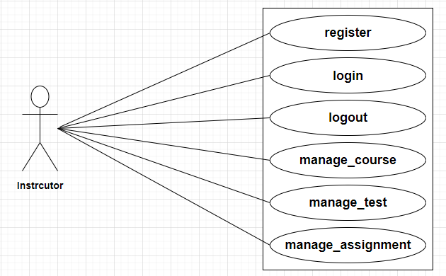

**Student :**

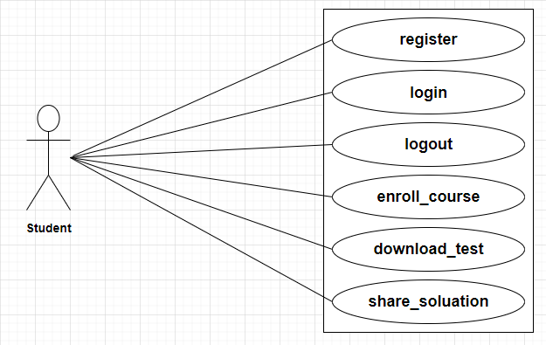

**Activity diagram:**

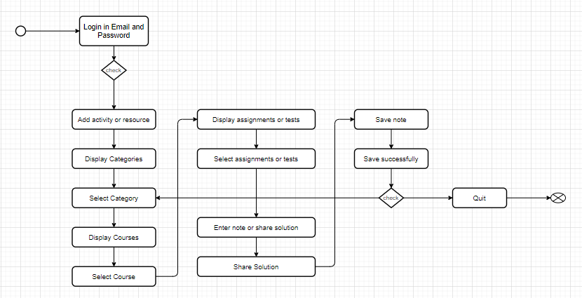

**Class diagram:**

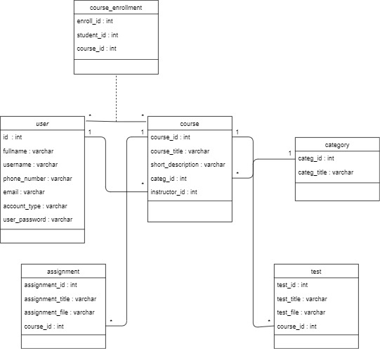

**Sequence diagram:**

**Login :**

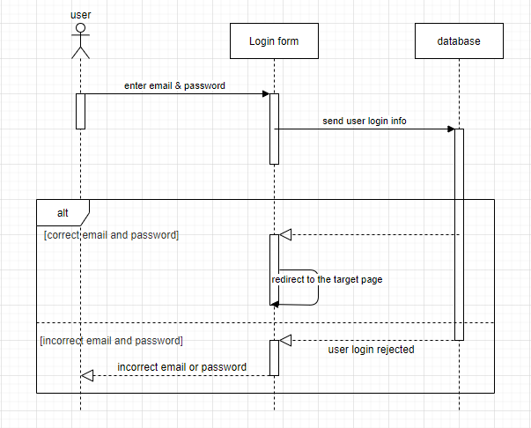

**Signup :**

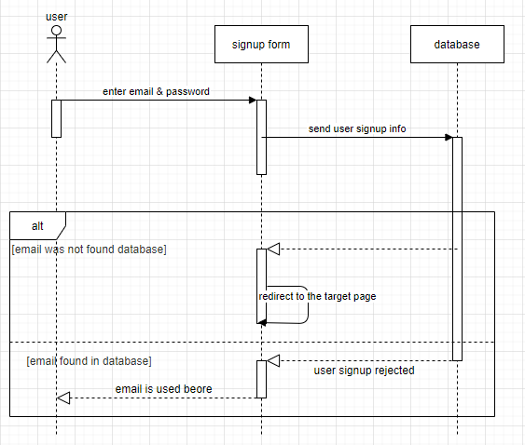

**Search :**

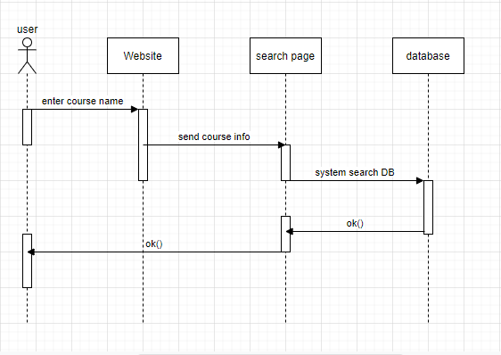

**Create :**

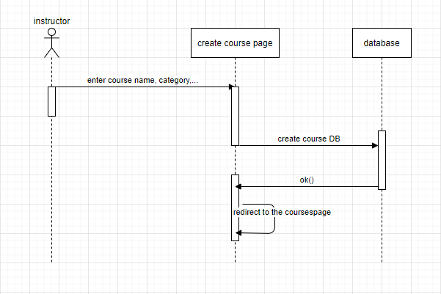

**Enroll :**

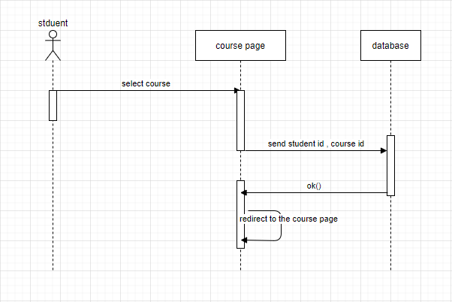

**Non-Functional Requirements :**

**Maintainability:**     

• Software must be developed to meet changes.

 • Accept the new requirement.

 • Allow changing the format.

**Reliability:** • The system that is to be developed is real not an ideal.

• The system does not allow unauthorized users to login.

**Usability:**

• The system should be easy to use by Staff.

• And our system gives direct input on how real users use the system.  
**Availability:**

• The system must operate 99% at working time**.**

• We must make sure that the system be accessible for all authorized staff and not accessibility by anyone else.

**Flexibility:**         • The system must support commonly usable browsers.

**Security:**•The authenticate users should have a privilege to access the database.

•The system does not allow unauthorized users to login.